SQL Query For To Finf the 2nd Highest Salary From Employess Tables

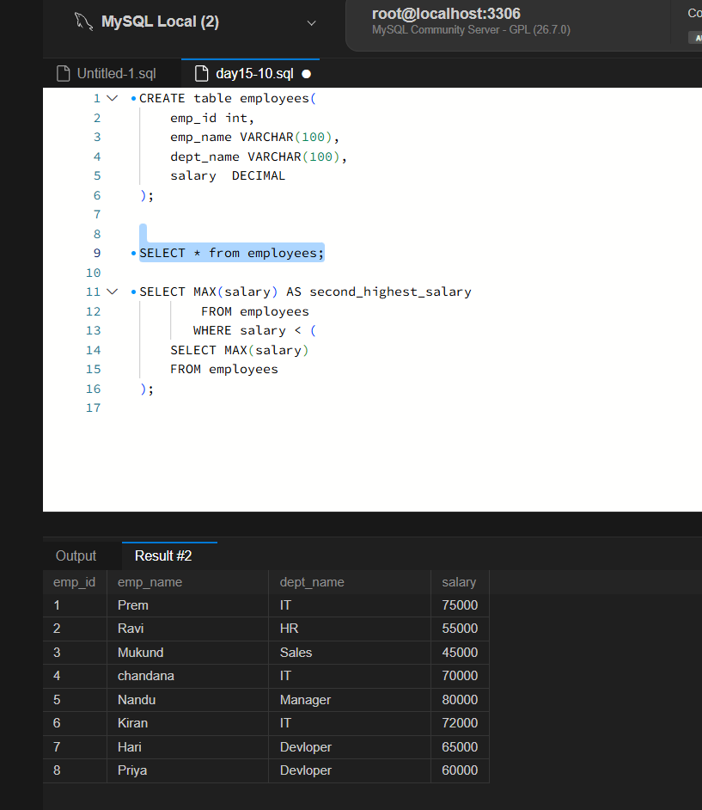

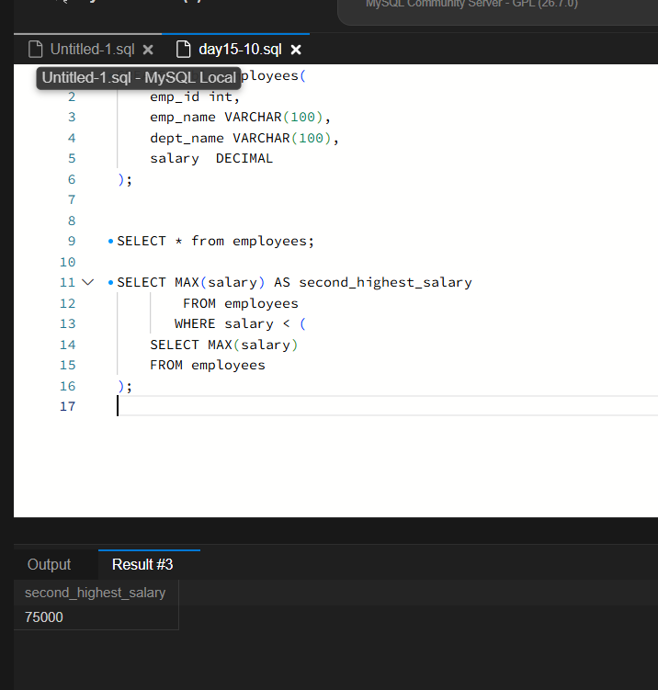

Linux Commands For Current Working Dirctory, Create Directory, Create Two Files, List the files, and path and File Names

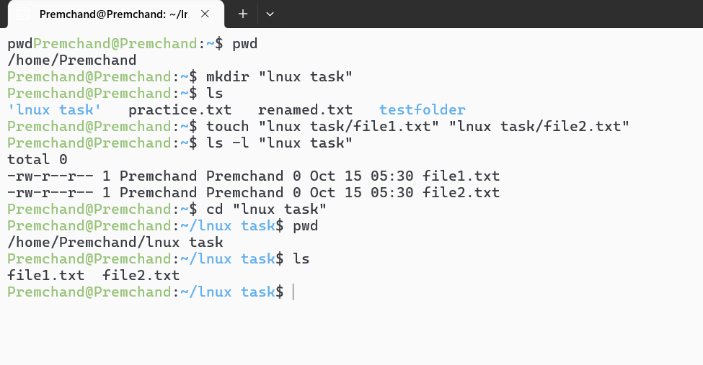

AWS EC2 Instance Current State, Instanace Type, and Public IP Address

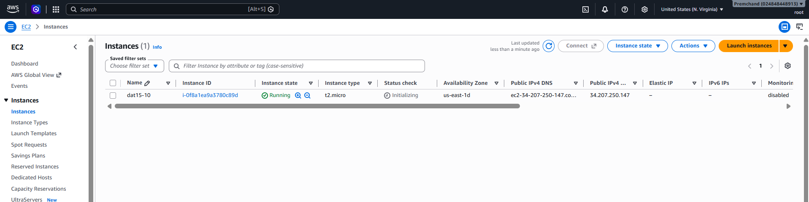

AWS IAM - S3 Read Only policy

Role created and added permission For S3 Read only
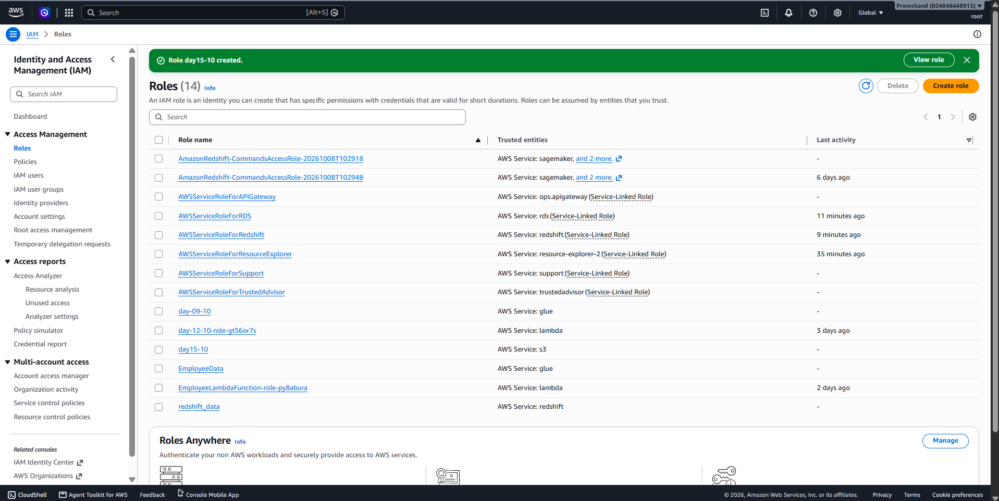

File Uploaded to S3 Bucket
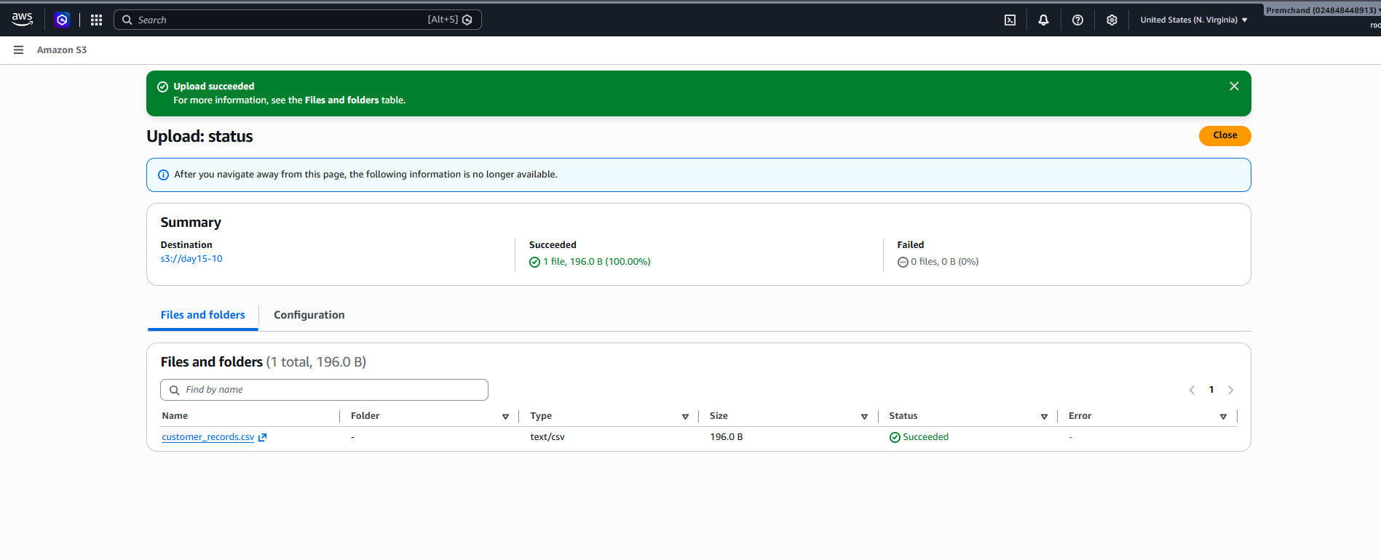

Azure Resource group create with name PracticalRG

